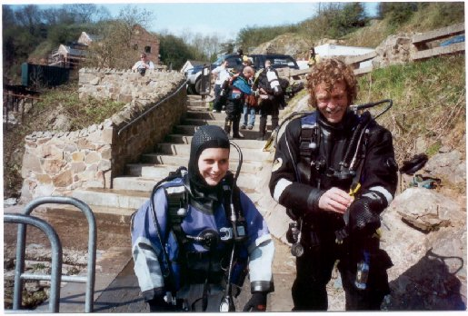 | 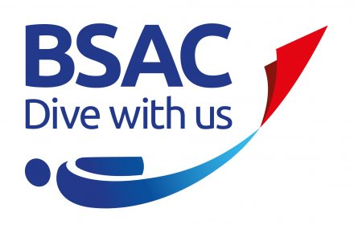
This Voucher entitles the holder to
A TRY-DIVE with
Prima Sub-Aqua
At a special price of £10.00

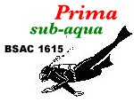 | Have you got the urge to submerge?  Ever wondered what life is like under the water?  Now's your chance to find out, no obligation.  You provide the swimwear, we provide the experience.
http://www.prima-sub-aqua.co.uk  Cheslyn Hay Leisure Centre  Every Tuesday 8:00pm | To claim your TRY DIVE or just to get more information please contact:  training@prima-sub-aqua.co.uk  To arrange a convenient date

